20240829.28

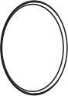

Smart Button



T H I RD R EAL I TY

Mounting Kit   |  |  |   Double-sided Tape
AAA Battery x 2
Magnet Sticker x 2 |  |  | Icon Sticker x 9
LED Status
ZigBee Pairing: fast blinking in blue
Echo ZigBee pairing: fast blinking in blue and red Oﬀ-line: slow blinking in red
Low power: double blinking in red
* To switch mode between standard ZigBee mode and Echo ZigBee mode by pressing the reset button for 5 times within 5 seconds.
LED Indicator

1

Setting up your Smart Button

1. Follow instructions to set up your compatible ZigBee hub.
2. Slide the battery cover out (ﬁgure 1) and remove the bat- tery insulation sheet.
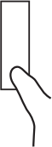        PUSH    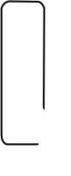  l | 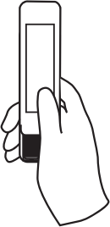 |  | 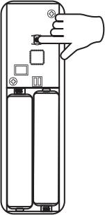
3. The LED indicator ﬂashes rapidly in blue, indicating that the Smart Button is in pairing mode by default.
*If the Smart Button is not in paring mode, press and hold the reset button for 5 seconds (Figure 2) until the LED indi- cator ﬂashes rapidly in blue, indicating that it is in pairing mode.
4. Conﬁgure the Smart Button with your ZigBee hub.
5. Close the Smart Button's battery cover.
6. After the pairing is completed, you can create routines in the corresponding smart home App or platform to control other connected devices.
THIRDREALITY Smart Button supports three control set-
tings: Pressed, Double Pressed and Held. 2

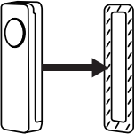
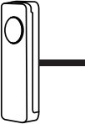
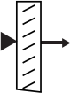

Install your Smart Button

We provide two diﬀerent installation methods, place your Smart Button according to your requirement.
Using the double-sided tape that included:

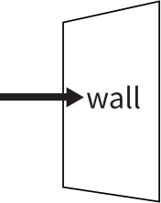

Double-sided Tape

Using the magnet stickers that included:

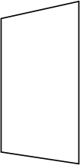

wall

Magnet Stickers

*Note: Smart Button is designed for indoor use only.

3

Pairing with Diﬀerent Brands of Hubs

Before pairing, check for updates to make sure the ﬁrm- ware of the hub is up to date.

1. Pairing with Hubitat Website: http://ﬁnd.hubitat.com/
Pairing steps:
1) Remove the battery cover of the Smart Button, remove the battery insulation sheet, the LED indicator ﬂashes quickly in blue, indicating the Smart Button is in pairing mode.
2） Visit your Hubitat Elevation hub device page from your
web browser, select the Devices menu item from the side- bar, then select Discover Devices in the upper right.
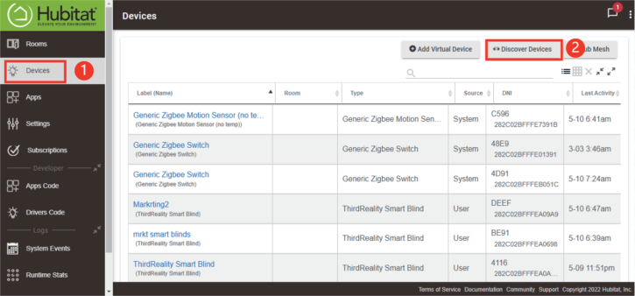
4

3) Click Start ZigBee Pairing button after you select a ZigBee device type, the Start ZigBee Pairing button will put the
hub into ZigBee pairing mode for 60 seconds.
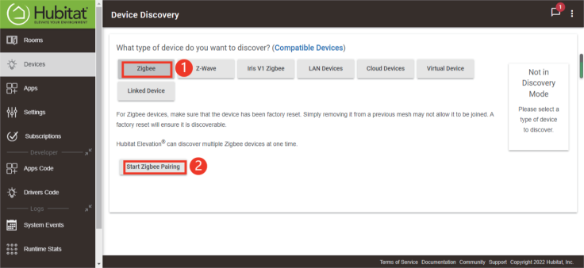
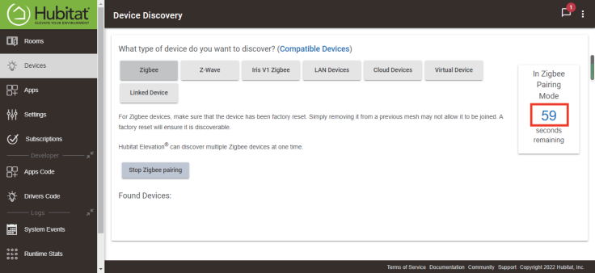
5

4) After being paired successfully, it will be showed on page as on page as "ThirdReality Smart Button", you can
rename it if needed, then tap "save".
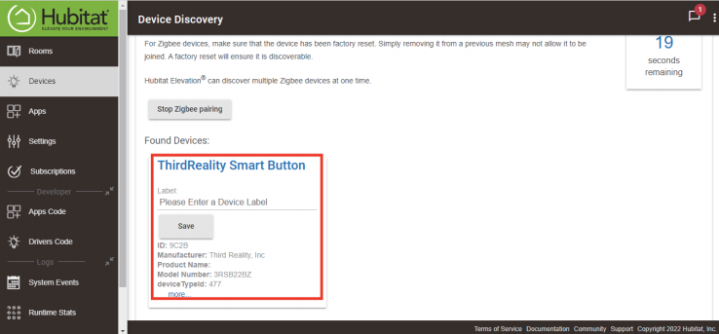
5) Now you can see the Smart Button on the Devices page.
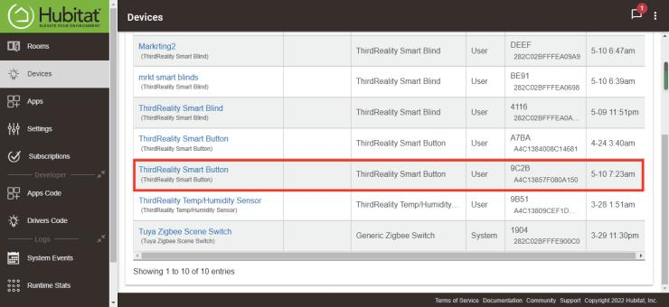
6

2. Pairing with Home Assistant through ZHA Pairing steps:
1) Remove the battery cover of the Smart Button, remove the battery insulation sheet, the LED indicator ﬂashes quickly in blue, indicating the Smart Button is in pairing mode.
2） Make sure Home Assistant Integrations ZigBee Home Au- tomation Setup is ready, thengo to "Conﬁguration" page, click "integration".
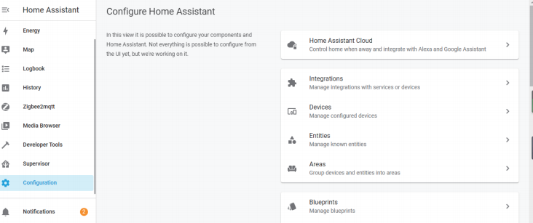
7

3) Then click the "Devices" on the ZigBee item, the click "Add Devices".
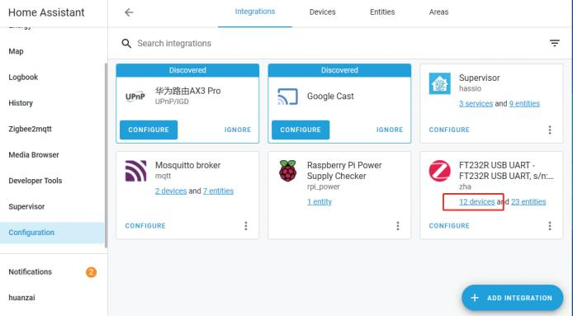
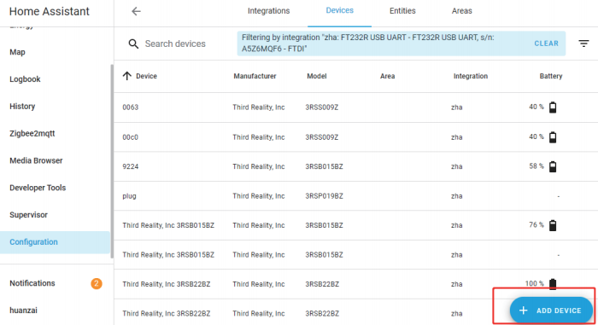
8

4) After the pairing is successful, it will show as "Third Reali- ty, Inc 3RSB22BZ" on the page.

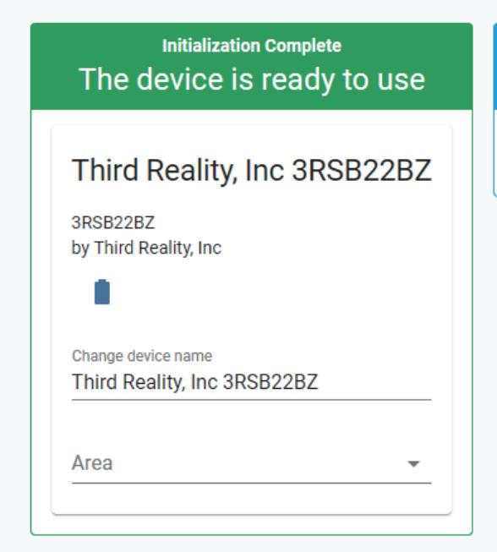

9

5) Back to "Devices" page, then you can ﬁnd the Smart
Button added before. Click to enter in the control interface to set the Smart Button.

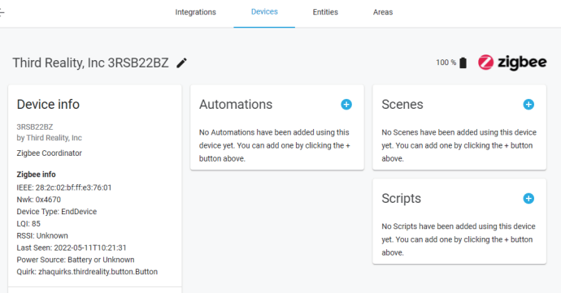

10

6) Click the "+" belongs to Automation and then you can add diﬀerent actions to Third Reality Smart Button.

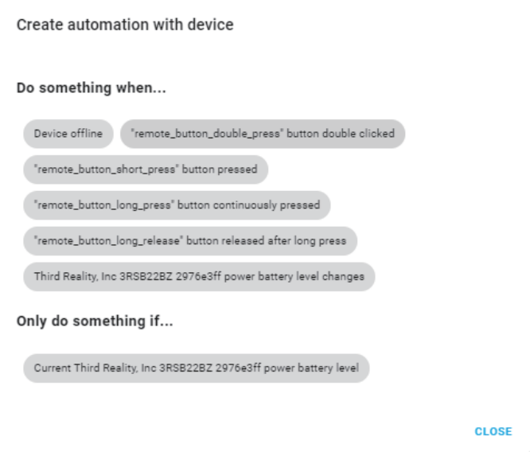

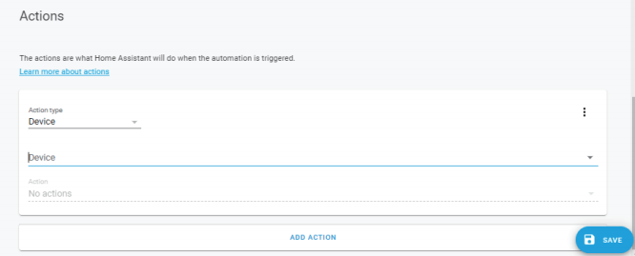
11

3. Pairing with Third Reality

ZigBee Hub Prepare: Third Reality Smart Hub App: Third Reality App

Pairing steps:

1) Remove the battery cover of the Smart Button, remove the battery insulation sheet, the LED indicator ﬂashes quickly in blue, indicating the Smart Button is in pairing mode.
2） Open Third Reality App, go to device page, tap "+" belongs to the Hub, choose "Smart Button" , then click "Pair".
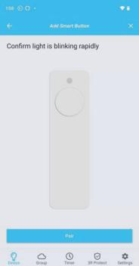 | 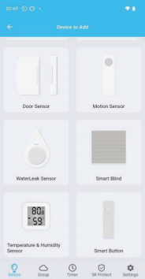 | 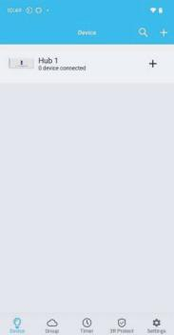  12

3) After the pairing is completed, tap "Complete", then back to main interface

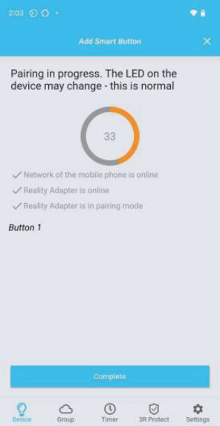

13

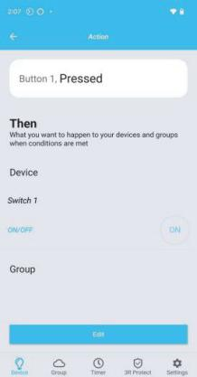
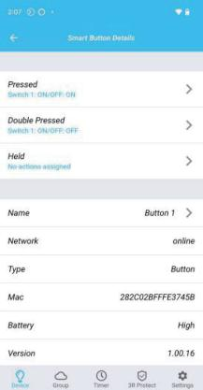

4) Tap "Smart Button" icon on device page, you can see the details, such as Battery, History Records etc. Then click
Pressed / Double Pressed / Held, you can create diﬀerent scenes.

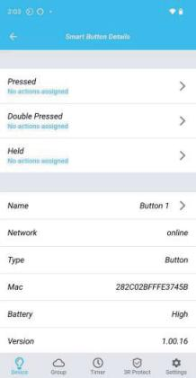

14

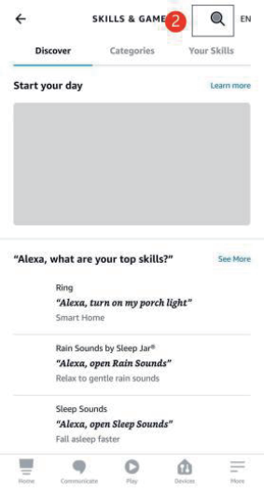

5) Or you can enable Third Reality SkillX to Alexa, follow the prompts and tap "DISCOVER DEVICES" in Alexa app, it will be recognized as 3 motion sensors as "Button 1 Click",
"Button 1 Double Click" and "Button 1 Long Click", then you can create routines to control other devices with the Smart Button.

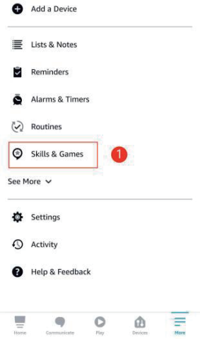

15

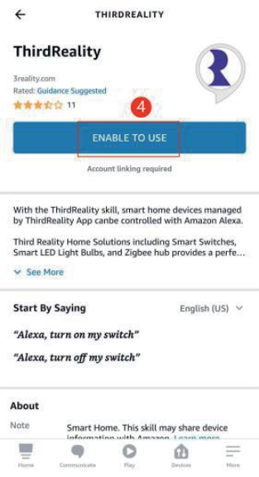

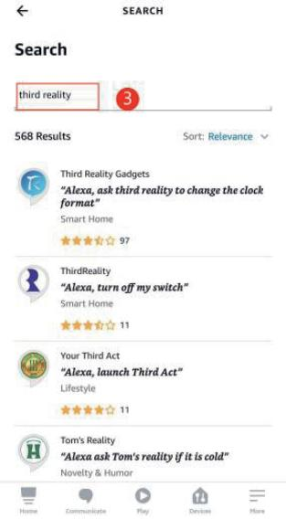

16

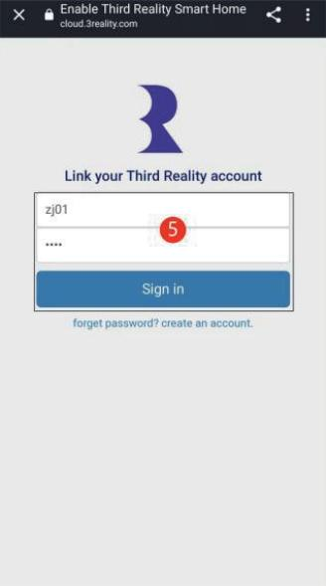

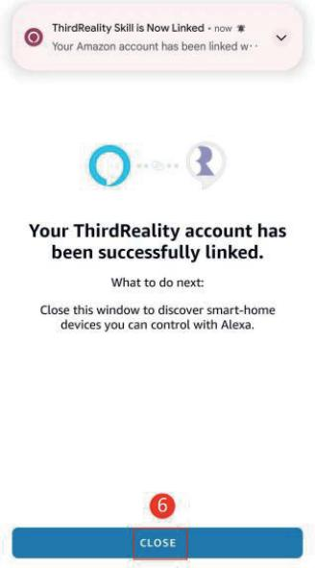

17

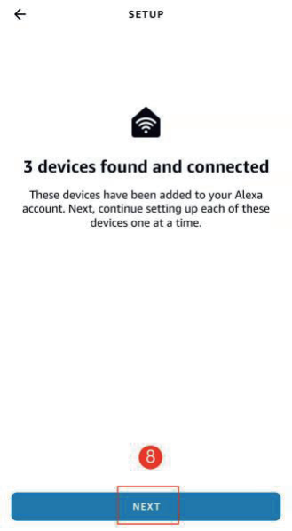

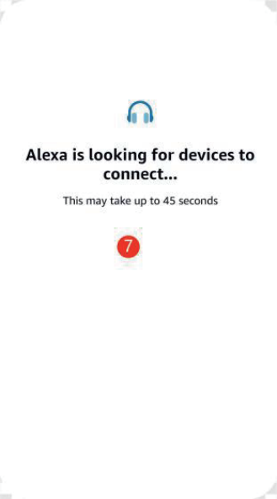

18

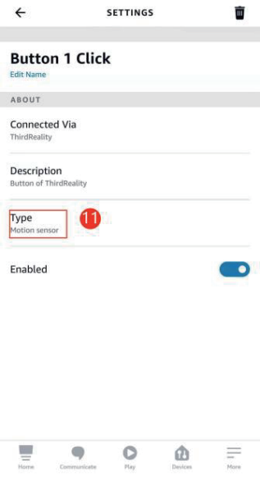

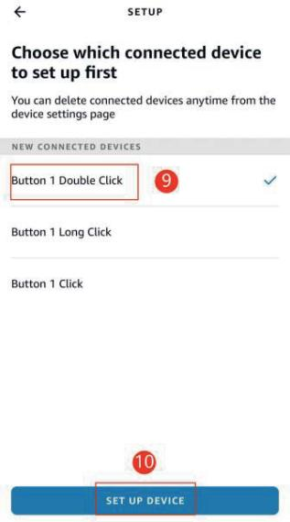

19

Pairing with Amazon Echo

App: Amazon Alexa App



Pairing with Echo devices with built-in ZigBee hubs such As Echo V4, Echo Plus V1 & V2, Echo Studio, and Eero 6 & 6 pro.

1) Ask Alexa to check for updates before pairing.
2） Remove the battery cover of the Smart Button, remove the battery insulation sheet and install the batteries, the LED indicator blinks quickly in blue. The Smart Button is in
standard ZigBee pairing mode.
3） To switch mode between standard ZigBee mode and Echo ZigBee mode by pressing the reset button for 5 times
within 5 seconds.

20

4) Ask Alexa to discover devices, or open Alexa App, go to
device page, tap "+" on top right, choose "Add Device",
scroll down to the bottom and tap "other", tap "DISCOVER DEVICES", the Smart Button will be paired with your Echo device in a few seconds, it is recognized as a motion
sensor.
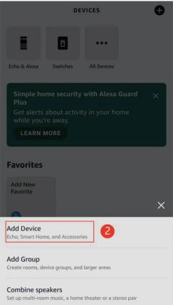
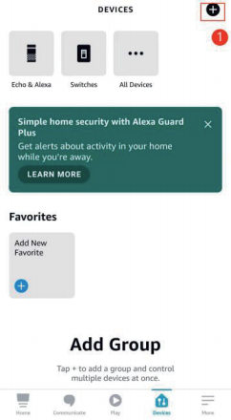
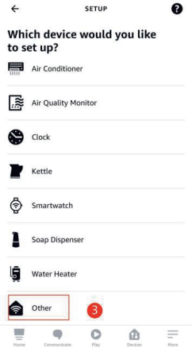

21

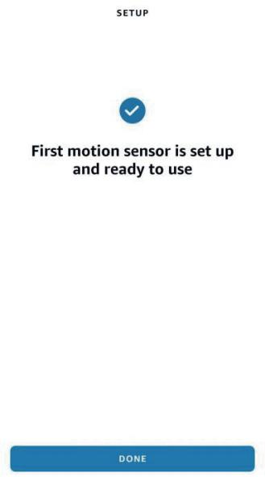

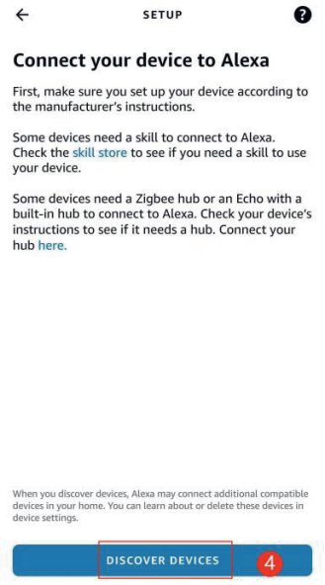

22

5) Tap "First Motion Sensor" in all devices list to open the
Smart Button device page, you can create routines with it to control other devices.
* Please be aware of that since Alexa sees Smart Button as a motion sensor which has a cool down time of 30 sec-
onds, in this case Smart Button can be triggered only once within 30 seconds.
* Please make sure you create 2 same routines for both
"motion detected" and "motion not detected", in order to avoid routine conﬂict.
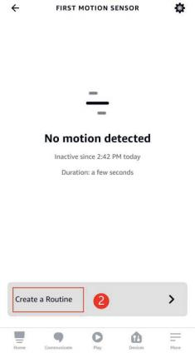
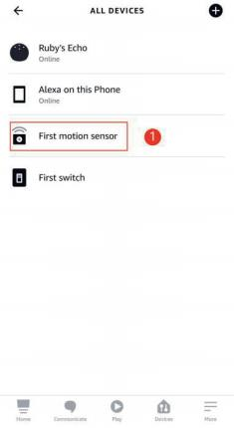
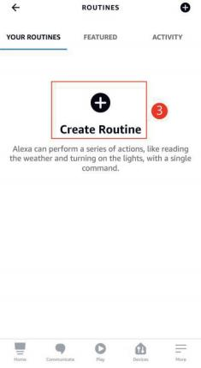

23

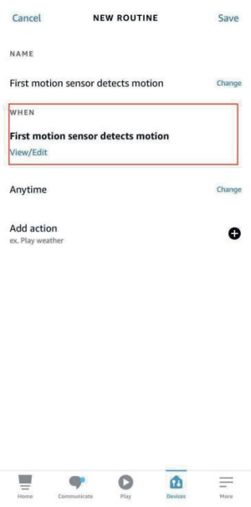

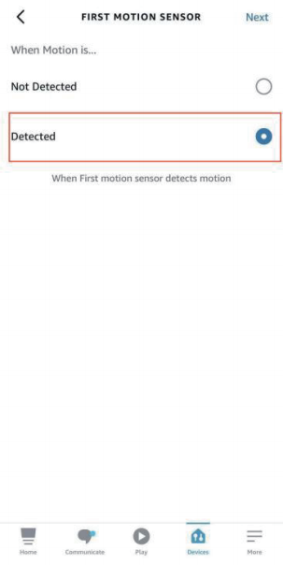

24

Pairing with SmartThings

App: SmartThings App
Devices: SmartThings Hub 2nd Gen(2015) and 3rd Gen.(2018), Aeotec Smart Home Hub.

Pairing steps:

1) Before pairing, check for updates to make sure the Smart- Things Hub ﬁrmware is up to date.
2） Add SmartThings drivers for ThirdReality Smart Button.

Open this link in your PC browser. Log in your SmartTh- ings Account.
https://bestow-regional.api.smartthings.com/invite/ad- MKr50EXzj9
Click "Enroll" --"Available Drivers" -- "Install" to install the device driver.

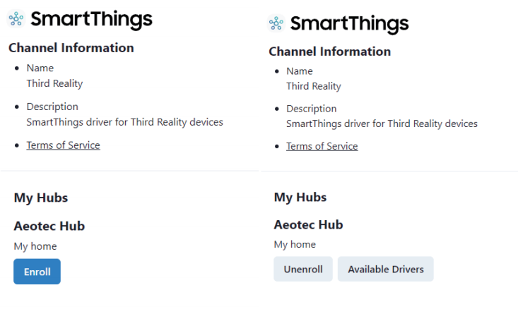

26

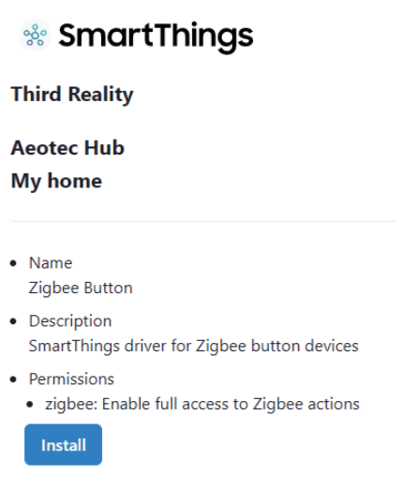

3) Remove the battery cover of the Smart Button, remove the battery insulation sheet and install the batteries, the LED indicator blinks quickly in blue. The Smart Button is in
standard ZigBee pairing mode.
4） Open the SmartThings App, tap “+”on the upper right corner to ”Add device”and then tap “Scan”to “Scan for nearby devices”.
5） The Smart Button will be paired with the SmartThings hub in a few seconds.
6） Create routines to control connected devices.

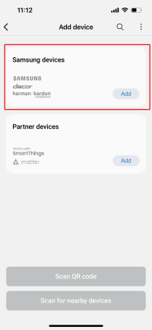
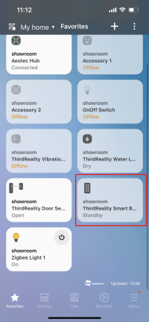
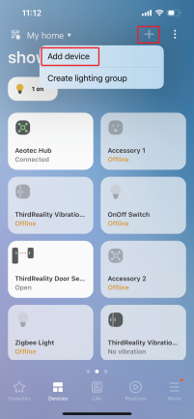

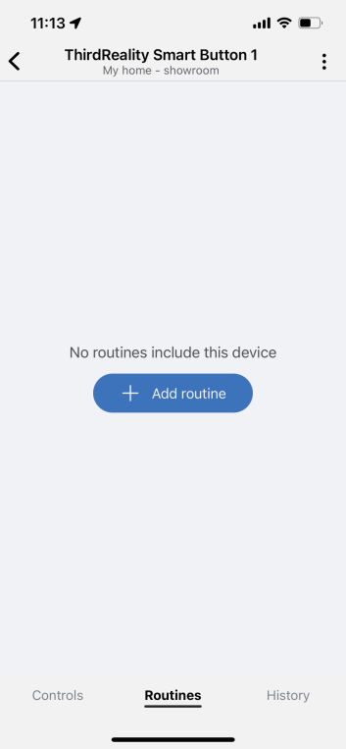

28

FAQ
1) How to factory reset the Smart Button?
Remove the back cover of the Smart Button, press and
hold the reset button on the back for 3 seconds, the LED
indicator will ﬂashes quickly, now it has been factory reset and in pairing mode.
2） How to change between 2 ZigBee pairing modes?
To switch mode between standard ZigBee mode and Echo ZigBee mode by pressing the reset button for 5 times
within 5 seconds. When the LED indicator blinks quickly in blue and red, it is in ZigBee pairing mode for Echo devices. When the LED indicator blinks quickly in blue, it is in
ZigBee pairing mode for other ZigBee hubs like SmartTh- ings Hub etc..

29

FCC regulatory conformance

This device complies with part 15 of the FCC rules. Operation is subject to the following two conditions: (1) this device may not cause harmful interference, and (2) this device must accept
any interference received, including interference that may cause undesired operation.

Changes or modiﬁcations not expressly approved by the party responsible for compliance could
void the user’s authority to operate the equipment.

NOTE: This equipment has been tested and found to comply
with the limits for a Class B digital device, pursuant to part 15 of the FCC Rules. These limits are designed to provide reason- able protection against harmful interference in a residential
installation. This equipment generates uses and can radiate
radio frequency energy and, if not installed and used in accor- dance with the instructions, may cause harmful interference to radio communications. However, there is no guarantee that
interference will not occur in a particular installation. If this
equipment does cause harmful interference to radio or televi- sion reception, which can be determined by turning the equip- ment oﬀ and on, the user is encouraged to try to correct the
interference by one or more of the following measures:

30

‐ Reorient or relocate the receiving antenna.
‐ Increase the separation between the equipment and receiv- er.
‐Connect the equipment into an outlet on a circuit diﬀerent from that to which the receiver is connected.
‐Consult the dealer or an experienced radio/TV technician for help important announcement.

NOTE: The manufacturer is not responsible for any radio or TV interference caused by unauthorized modiﬁcations to this
equipment. Such modiﬁcations could void the user’s authori- ty to operate the equipment.

RF Exposure

This equipment complies with FCC radiation exposure limits set forth for an uncontrolled environment.
This transmitter must not be co-located or operating in con- junction with any other antenna or transmitter.

Limited Warranty

For limited warranty, please visit www.3reality.com/device- support
For customer support, please contact us at info@3reality.com or visit www.3reality.com
For help and troubleshooting related to Amazon Alexa, visit the Alexa app.
31

